Oil Tank Specifications

# Capacity

* Rotec R2800: 8L (6L of oil + 2L of airspace)
* Rotec R3600: 10L (8L of oil + 2L of airspace)

# Return ports

* Electric scavenger pump (optional)
* Mechanical scavenger pump
* Mini sump breather return
* Oil pressure relief valve return
* Tank Vent - Breather to atmosphere (baffled away from other ports)

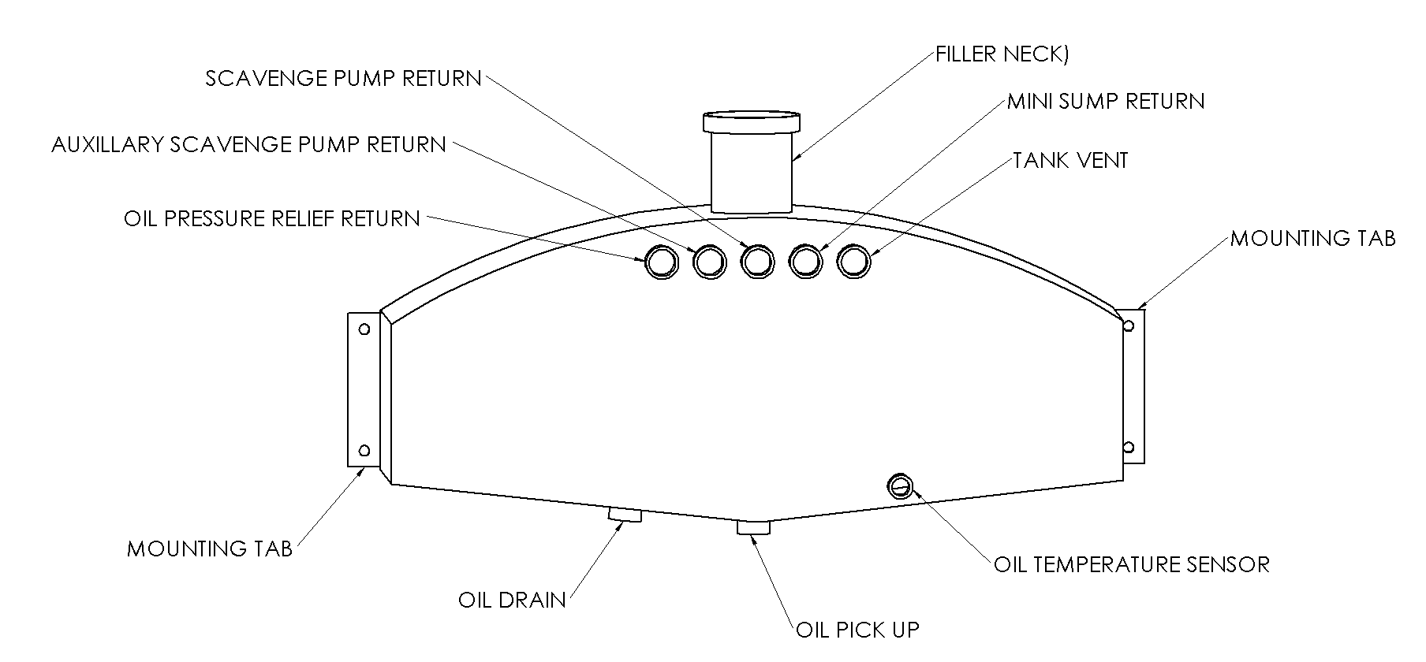

Figure 1: Important Features (Top Mounted Oil Tank shown here)

# Design

|  |  |  |
| --- | --- | --- |
| **Oil Tank Configurations** | | |
| **Top mount** | **Side mount** | **Custom design** |
|  |  |  |

Figure 2: Examples of Oil Tank Types

# Boundary dimensions:

**Length**: *(*please fill*)*

**Width**: *(please fill)*

**Height**: *(*please fill*)*

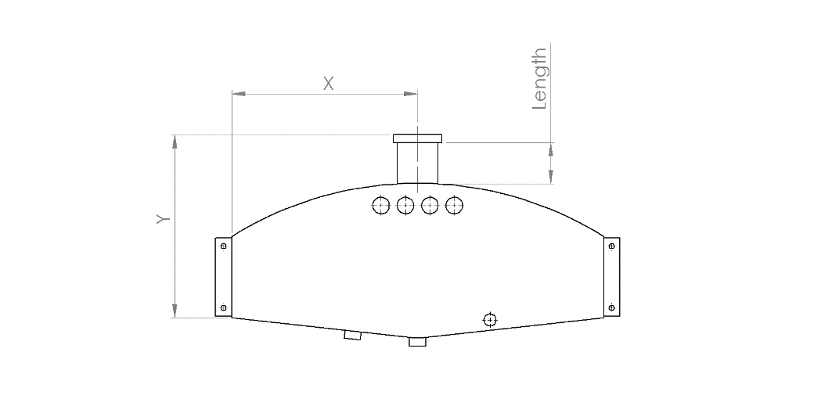

Figure 3: Reference Image-Filler Neck

# Oil Tank Filler Neck:

(Please specify what length and position desired)

* **Length/Height**:   
   *(*please fill*)* mm *or* inches
* **Position**:   
  *(*please indicate where you want the filler neck located*)*

# Mounting method:

* Mounting tabs (recommended/optional)
  + Which face(s)? (Please specify)

# Optional extras

* Oil drain sump plug

# Further Comments

(Please make any notes or recommendations for reference)